1. How to add Analysis Toolpak in Excel for a MacBook
- Open Microsoft Excel
- Click on “Tools” on the top toolbar
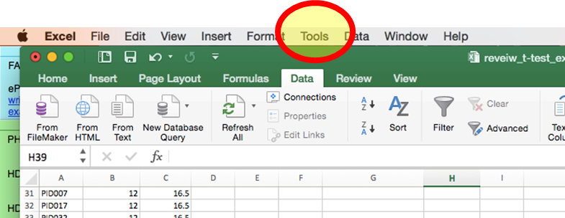

- Scroll to the bottom of the menu and click “Excel Add-ins”
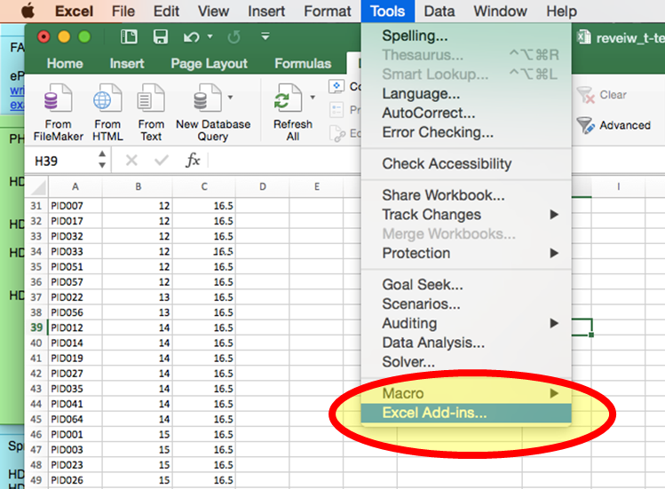

- Check the “Analysis ToolPak” box and click “OK”
